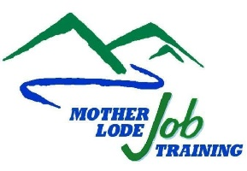
BOARD APPROVED ETP ASSURANCES FORM
Submit completed form in PDF to your Local Eligible Training Provider List (ETPL) Coordinator by email.

Part A.
I certify that [Insert Name of School/Organization]:
- Is a legal entity, registered to do business in California State;
- Has not been determined to be ineligible to receive federal funds;
- in compliance with Workforce Innovation and Opportunity Act Section 188 and Title 29 CFR Part 38;
- Has demonstrated effectiveness in operating occupational classroom or distance training program(s); and
- Agrees that training provider facilities, classroom instruction, relevant financial records, and attendance records may be reviewed by state, federal and/or local monitors or auditors to ensure compliance with funding requirements.

Part B.
I certify that I:
- Have reviewed the annual student data reporting requirements for the Eligible Training Provider ETP Performance Report (ETP Report) established for training providers. Refer to the ETP Report Required Data listed below;
- Will begin collecting required student data elements that are not currently being collected; and
- Will report and submit the ETP Report data for all students trained in each of my school/organization’s training programs listed as Board Approved to Mother Lode Job Training by the due date.

I understand that my school/organization’s application for Board Approval will not be processed without receiving this Eligible Training Provider Assurances Form.

Name of Training Provider (School/Organization)
Mailing Address
City, State, Zip Code
Phone Number (###) ###-####
Print Name of School/Organization Representative
Title of School/Organization Representative
_________________________________________  Signature of School/Organization Representative | Date

